

***ZONKED - An Unknown World* Documentation**

INDPR2

**Luis Da Costa Almeida**

**26 January 2021**

**BTS GP Promo 3**

Table of Contents

1. Game & Level Design 3

1.1. Overview 3

1.2. Story 3

1.3. Platform & Genre 3

1.4. Core Gameplay 3

1.5. Level Design 3

1.6. Enemies & Collectibles 3

1.7. Controls 3

1.8. Visual Style 3

2. NULL2 Building Guide 3

2.1. Necessary Equipment 3

2.2. Soldering the Raspberry Pi 3

2.3. Charging Port 4

2.4. Green Board 5

2.5. Headphone Board 5

2.6. Buttons and Switches 7

2.7. Speakers 8

2.8. LCD Screen 8

3. Conclusion 9

4. Presentation 9

4.1. Screenshots and Link to the Portfolio 9

4.2. Trailer 9

4.3. Flyer 9

# Game & Level Design

## Overview

*Game title here* is an action-platformer developed as part of a school project for the BTS Game Programming and Design. In this game you play as an alien that crash landed on an unknown planet. During the fall, a lot of his ship parts were spread all over the area and he needs to find them and return back to his ship all the while facing the aggressive native creatures of this planet.

Depending on how many parts you were able to find, you get a different ending at the end of the game.

## Platform & Genre

As already mentioned the game is an action-platformer and as such you’ll have to master tricky jumps and shoot your way through the levels. The game was made using GB Studio 3.0 and as such looks and acts like a Gameboy game. The game, can be played on itch.io and on the Null2 Kit.

## Core Gameplay

The game consists of three distinct levels. All getting progressively longer and harder as you progress. You, the player, have the ability to jump and shoot as well as collecting gears that are placed on the levels. Enemies can only be defeated by shooting them, some can take more hits than others and if yourself come into contact with one of them you’ll lose health.

You can take up to three hits before it’s game over. When you die, you’ll have to start the game from the beginning and try again. Thankfully to make things more manageable, you can find healing podiums that restore the entire health of the player.

## Level Design

## Level 1

The first level starts with the player standing on top of a cliff, when they start to move they’ll eventually encounter a pit which they can jump over and jump off should they fall in. Not too much longer they’ll encounter the first enemy which is a simple slime that can be defeated with one shot.

When reaching the end of the cliff the player is forced to jump down, which brings them to the next level and they learn first hand that there’s no fall damage in the game. The level continues with another slime encounter and a new enemy that can fly around for a limited distance. The level is followed by jumping over spikes that can kill the player on immediate contact and eventually they reach their first healing podium just before the next level.

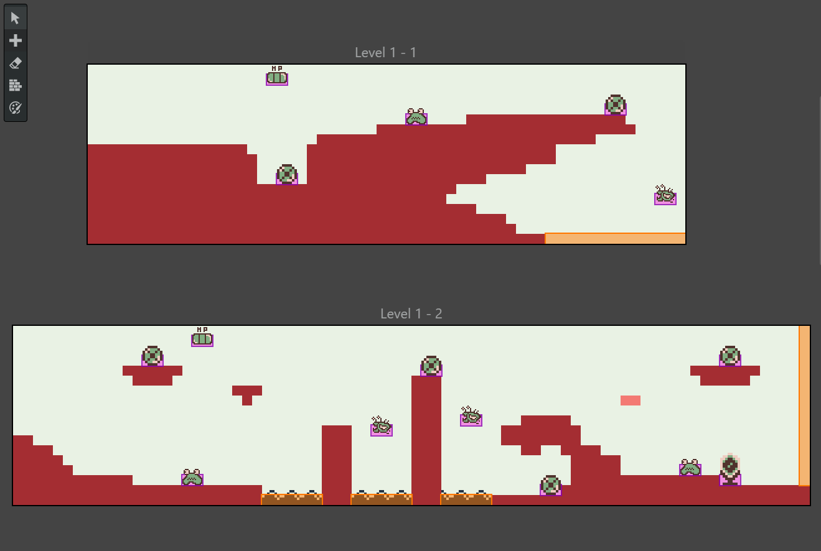

## Level 2

The second level starts of with another slime enemy and flying enemy later on the player meets a new enemy type that is a lot larger and can take more hits then the others. It moves by jumping diagonally and follows the player around whenever it’s on screen. When they get past that enemy they enter a cave as represented by the colour switch. There they jump down from platform to platform until they reach the next section where they are greeted by another healing podium.

The last third of the second level is a bit more maze like and limits the players jumping capacity. There they have to be more careful as there are also spikes on top of the wall which can lead to death.

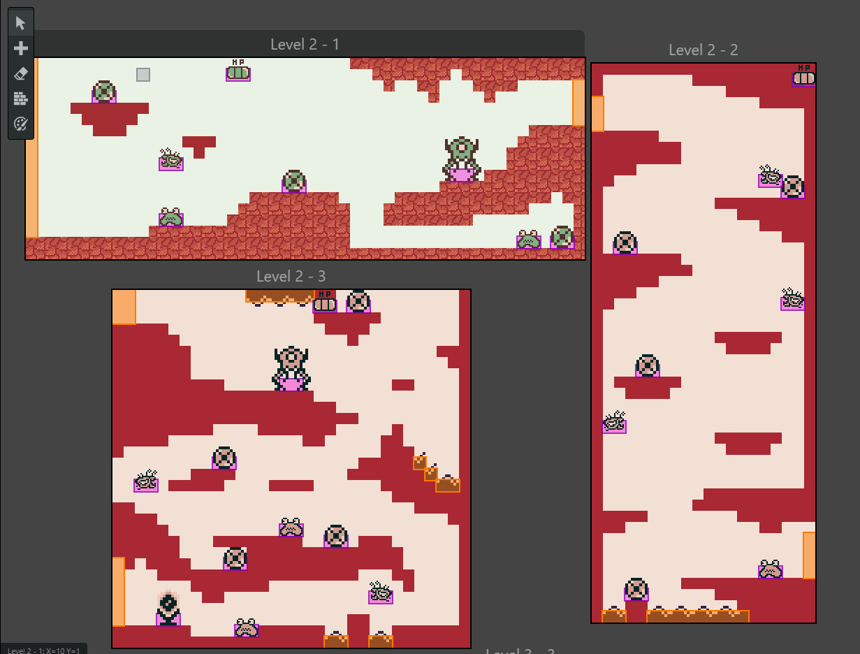

## Level 3

The last level is also the longest, it starts on the same place as the previous level at the top of a small cliff the player now needs to make their way down while more and more dangerous enemies and spikes appear. The second part involves the player climbing up the platforms, which is the inverse of the second level’s second section. The next part involves the player on jumping from one platform to the next all while flying enemies are between each platform. Falling would result in death making this an all or nothing type situation. If the player is able to prevail they’ll finally leave the cave and can make their way to their UFO finishing the game.

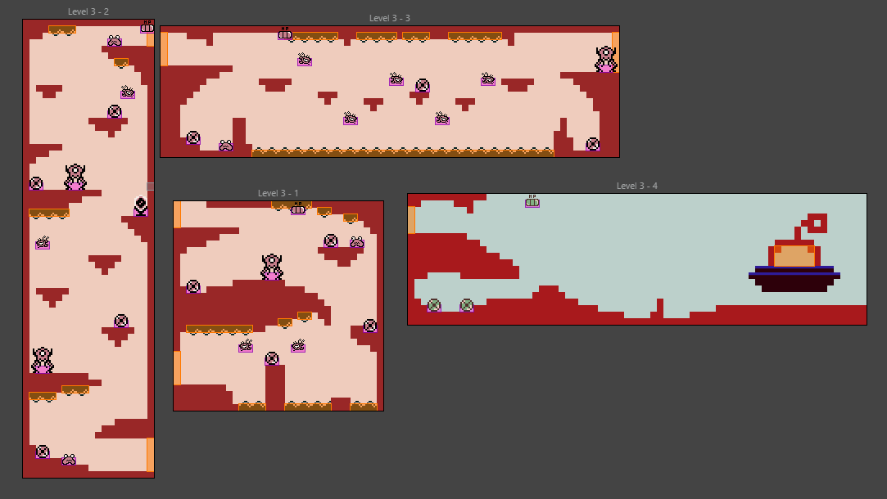

## Enemies & Collectibles

* Slime:
  + Walks left and right by 6 pixels relative to its position
  + Dies in one shot
  + Gives the player one damage point
* Flappy:
  + Can fly left and right by 6 pixels relative to its position or up and down by 10
  + Dies in two shot
  + Gives the player one damage point
* Jumper:
  + Follows the player by jumping up 4 pixels all while moving 2 pixels on the x axis
  + Dies in four shot
  + Gives the player one damage point

## Controls

* Digital Pad Left 🡪 Move Left
* Digital Pad Right 🡪 Move Right
* A 🡪 Jump
* B 🡪 Shoot

# NULL2 Building Guide

## Necessary Equipment

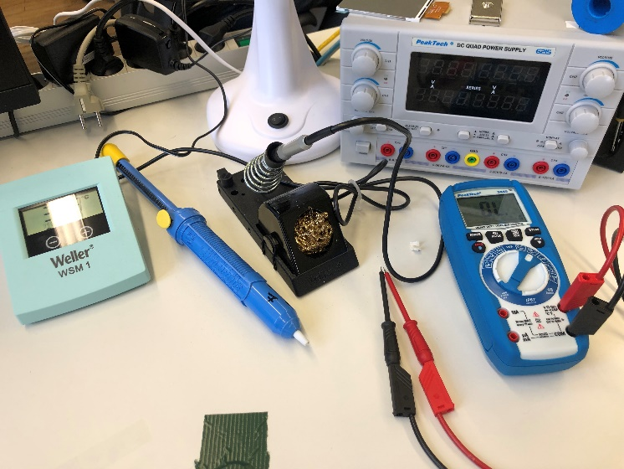Before we start building anything, we need to have the proper equipment by our side. Luckily there’s not a lot that you need to fully build the Null2.

The equipment required are the following:

* Soldering Iron
* 1mm thick foam tape
* Multimeter

## Soldering the Raspberry Pi

To start off, make sure that you tape the main board on your table before you start solder the raspberry pi. This will help you to keep it steady. After that, put the raspberry pi on the same position as shown on the image below. Make sure that when you solder it, that the soldering tin is pushed down as much as possible to assure a connection between the two boards.

You can check it, by using the multimeter and putting the pins on the two points that are supposed to be connected with. If you hear a sound from the machine then there’s a connection.

Ein Bild, das Text, Elektronik enthält.

## Charging Port

Next up we solder the charging port, the process is similar to the raspberry pi. Since it’s quite a bit smaller, make sure to tape it properly first to help you solder the first two holes. Regarding the two holes next to the actual port, it is recommended that you put a bit of a steel … to help stabilize it further.

Ein Bild, das Text enthält.
Ein Bild, das Text, Elektronik, Schaltkreis enthält.

## Green Board

The green board is very straight forward. Place it on the upper left corner of the main board. Make sure that the “IN” and “OUT” both marked on the green board and the PCB are facing the same direction. If you’ve done that then you can start soldering all six holes. Make sure to always test your connections with the multimeter by following the white lines.

Ein Bild, das Text, Elektronik, Schaltkreis enthält.

## Headphone Board

Up next, we have the headphone board. This is one is a bit tricky and requires a few extra steps before we can solder the board on the PCM.

First, we need to solder pins into the PCM on which we’ll later solder the board on. It’s important that the headphone board has a fairly smooth surface, without any pins sticking out, for the casing. To assure that we put the pins on the headphone boards and use pilers to move the pins one by one so that we have a flat side.

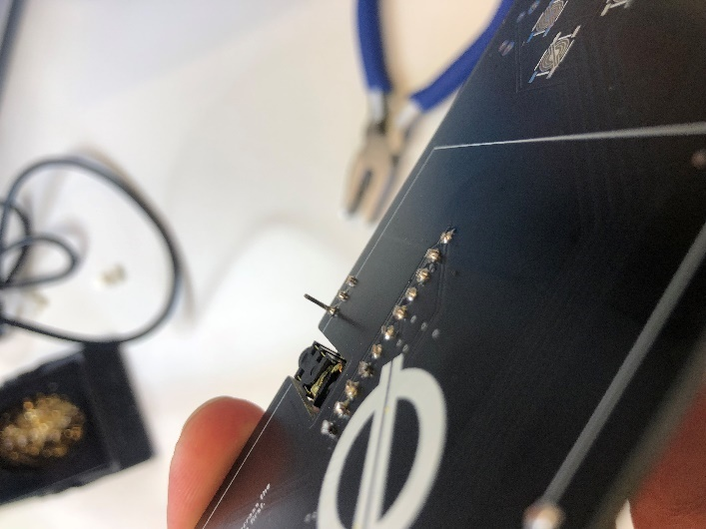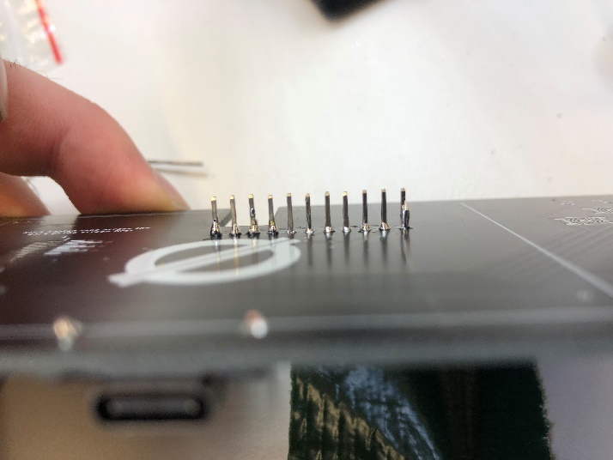Ein Bild, das Text enthält.
After that we can put the pins on the board and start soldering them and then cut off the excess part that are sticking out from the PCM.

Ein Bild, das Text, Elektronik, Schaltkreis enthält.
Having done all that, we can now put the headphone board on top of the pins and soldering them together with the board.

## Buttons and Switches

Ein Bild, das drinnen enthält.
This part is also very straight forward, there are three shoulder buttons. One for each upper side and one for the bottom left. Just stick those into their respective places and solder them in place.

Now we’ll take care of our two switches. One for turning on the power and one for the volume. Soldering them is practically the same as with the back buttons. Just put them into place and solder them from behind.

The last buttons are the start and select buttons. These are a bit trickier because of their small size. I’d recommend to put a bit of tape on one half of it, to make sure that it aligns with the metal connections, and solder it in place. After that you can take the tape of and do the rest.

Ein Bild, das Text, drinnen enthält.
Ein Bild, das Text, Elektronik, Schaltkreis enthält.

## Speakers

Ein Bild, das Zahnrad enthält.
We have two speakers that need to be connected. They have tape behind that you can peel off to tape it on the PCM. Before you do that however, make sure to solder it first. The red wire goes into the positive pad and the black one goes into the negative pad. The pads are marked with a plus and minus. After that you can tape it on the board to secure it properly.

## LCD Screen

Our last component to solder is the LCD screen. To do that we have to use it’s ribbon cable and solder the connections marked on with the pads shown on the PCM board. Use tape to make sure that both markings align with each other and to prevent any mistakes. Then I’d recommend to use thin soldering tin as to not accidentally overflow the markings with tin. Do it precisely for each connection and you should be finished with the screen.

Ein Bild, das Text, Elektronik enthält.
Ein Bild, das Text enthält.

To make sure that the screen sticks to the main board, use some double sided tape and put it on the bottom side of the screen. Then place it on top of the board and put a bit of pressure to make sure that it sticks.

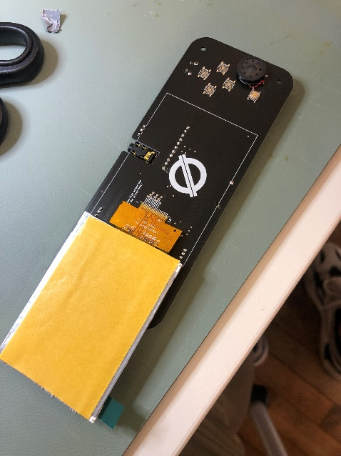

## Battery

The last thing to sold is the battery. Put the battery close to the charging port and connect the red cable to the with the *B+* hole and the black cable with *B-* . If you did everything correctly the screen should light up when turning the console on.

Ein Bild, das Text, Elektronik enthält.

## The casing for the console

As for the case, I downloaded a model of the site, [Thingiverse](https://www.thingiverse.com/thing:4910902). The model was made by the user Avoman on July 17, 2021. After downloading the case I used a 3D printer to print it out. I didn’t make a custom model as I feel that the main board is to wide and restrictive to make something that deviates from the original design without becoming uncomfortable to hold and play.

# Conclusion

I like the idea and concept of this project, having a game that you made yourself and a system to boot it on is probably a very satisfying accomplishment. Even though there were quite a lot of problems with getting the raspberry pi to work on it. My favourite part of the project by far was creating whatever game you like on GB Studio, despite it’s quirks. Having to adapt the game to the limitations of the console was interesting challenge to tackle and gave me a new appreciation for the comfort of modern engines.

# Presentation

## Screenshots and Link to the Portfolio

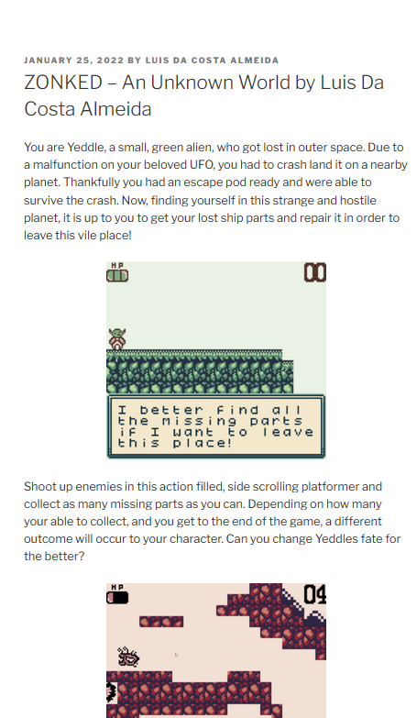

## Trailer

## Flyer

